What is gulucosamaine drink?

What is liquid glucosamine good for?

People use glucosamine sulfate orally to treat a painful condition caused by the inflammation, breakdown and eventual loss of cartilage (osteoarthritis).

Advantages of Liquids

Kind

Work and Effect

Does liquid glucosamine really work?

Early research suggests that oral use of glucosamine hydrochloride might reduce pain related to rheumatoid arthritis. However, researchers didn't see an improvement in inflammation or the number of painful or swollen joints.

How long does liquid glucosamine take to work?

Reported improvement (e.g. reduction in painful symptoms) varies from three weeks to as much as eight weeks. Some studies have shown continued improvement of symptoms after oral intake was stopped. Generally, if there is no pain reduction after two months, there is little chance of improvement.

What happens if you take glucosamine every day?

Glucosamine hydrochloride is possibly safe for most adults when used for up to 2 years. N-acetyl glucosamine is also possibly safe when used for up to 6 months. Glucosamine can cause some mild side effects including bloating, nausea, diarrhea, and constipation.

How does glucosamine work in the body?

Glucosamine, which is produced naturally in the body, plays a key role in building cartilage; the tough connective tissue that cushions the joints. Several scientific studies suggest that glucosamine may be an effective treatment for osteoarthritis (OA).

What are the side effects of liquid glucosamine?

Some side effects may include diarrhea, heartburn, constipation, and nausea. Other things to be aware of when taking glucosamine include drowsiness, headaches, and mild skin reactions. If your side effects are severe or don't go away after several days, stop taking glucosamine and contact your doctor right away.

Negative Effect

Side effects of glucosamine may include: Nausea (feeling like you're going to throw up) Diarrhea (loose or watery bowel movements) Abdominal (belly) pain Heartburn Itching Skin rash Temporary memory loss Low blood pressure Sleepiness Trouble breathing.2024年9月23日

Caution

Why do doctors not recommend glucosamine?

However, glucosamine may cause increases in blood glucose (sugar) levels in some people, and glucosamine and chondroitin have been associated with an increased risk of bleeding in people who are taking the anticoagulant warfarin.

Dosage

Manufacture process

Material

Production area

Package and price

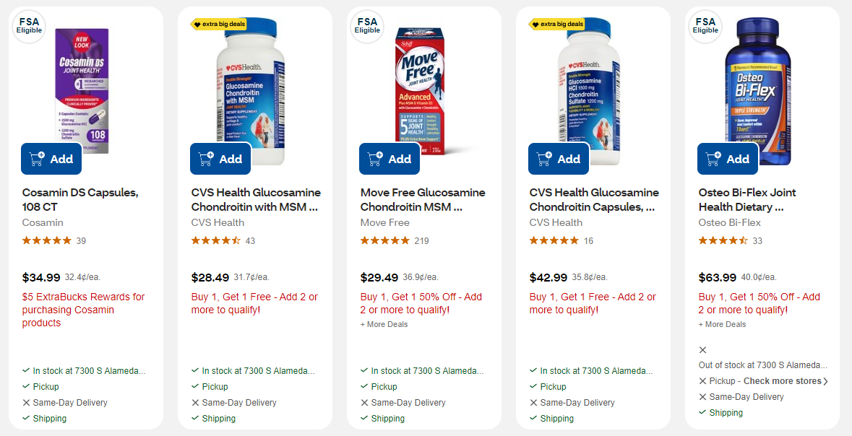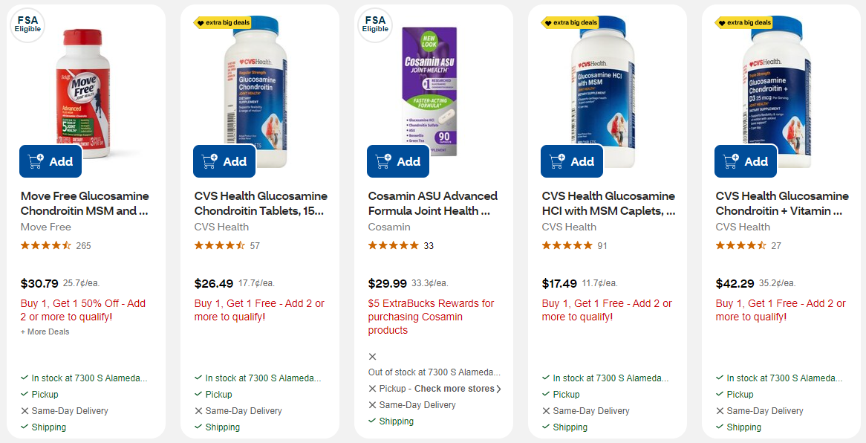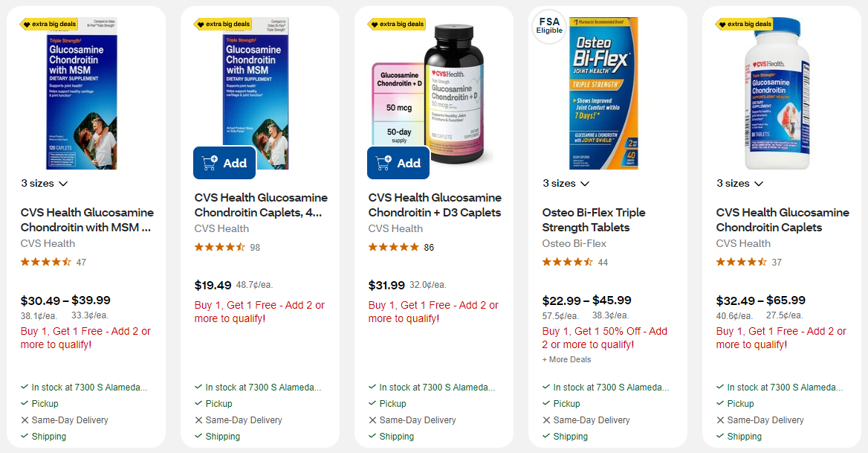

Example of one:

# Cosamin DS Capsules, 108 CT

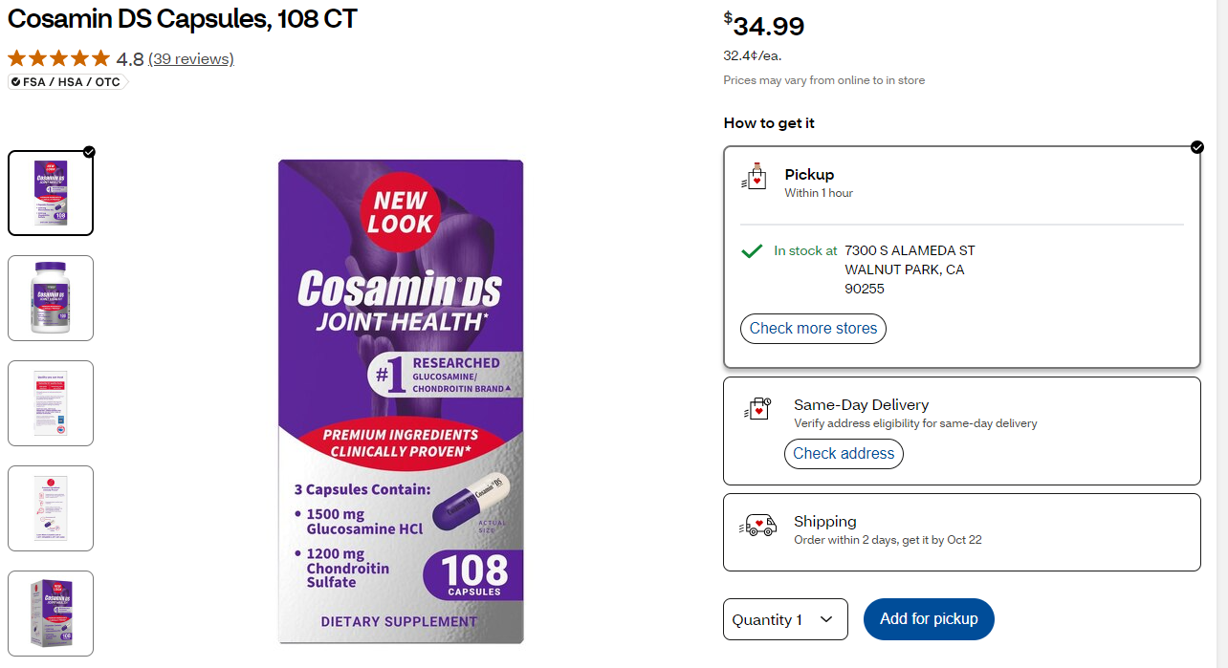

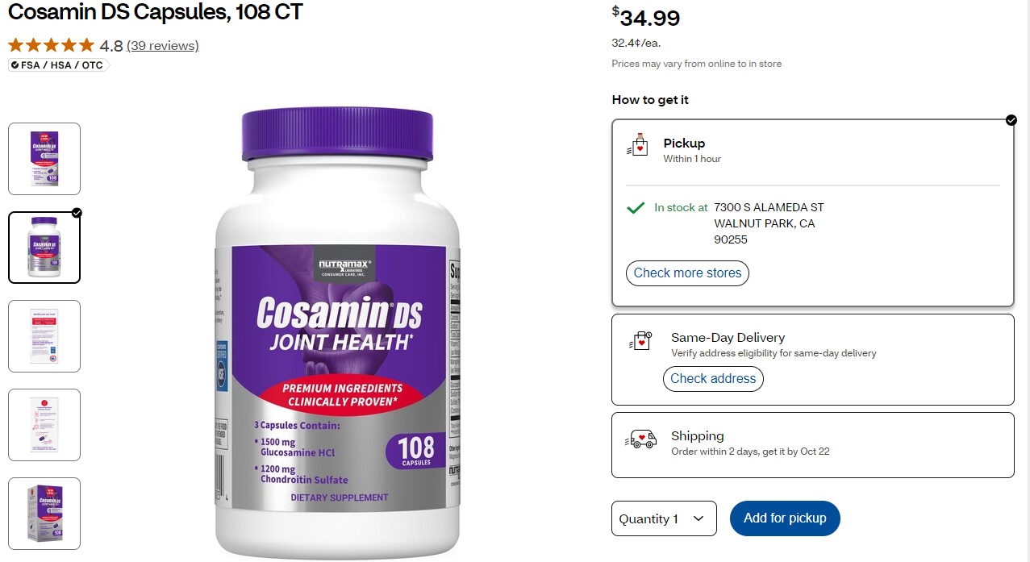

Details:

Cosamin DS Capsules, 108 CT

108.00 Ct, 0.1 lbs. Item # 454033

When it comes to your joints, there’s comfort in knowing that Cosamin® is proven by more research than any other leading joint supplement.* Cosamin® DS is proven to be effective in U.S. published clinical studies on joint health.* The revolutionary formula of ingredients work together to promote joint comfort at the cellular level, helping to block certain enzymes that break down cartilage*. The combination of our Glucosamine HCl and Chondroitin Sulfate in our joint supplement has been shown in cell culture research to decrease levels of markers associated with cartilage breakdown and joint discomfort.*These statements have not been evaluated by the food and drug administration. This product is not intended to diagnose, treat, cure, or prevent any disease *Based on top 10 brands of data reported by Nielsen through its AOD Service for the Supplement Category for the 52-week period ending 12/31/2021 for the U.S. market.

* This item is part of our Tested to be Trusted program
* As our commitment to you and your family, we require third-party laboratory testing of all vitamins and supplements
* A product sample is tested for certain contaminants and, whenever possible, the identity and potency of dietary ingredients
* Our suppliers are required to manufacture products in facilities that are registered with the FDA.
* Joint Health Support: This joint supplement contains the combination of 1500 mg Glucosamine HCl (FCHG49®) and 1200 mg Chondroitin Sulfate (TRH122®) that work together to help inhibit certain enzymes that break down cartilage and help promote joint comfort and mobility
* Clinically Proven: Supported by more published research than any leading joint supplement. The revolutionary formula of ingredients work together to promote joint comfort at the cellular level, helping to block certain enzymes that break down cartilage
* Cartilage Support: Cartilage in the joint is produced and maintained by its own specialized cells. The protective cartilage cushion and joint fluid work together like a shock absorber to allow for proper joint function
* Scientifically Researched High-Quality Ingredients: Developed by a pharmacist, Cosamin® is made with the utmost care and integrity by the same family-owned, American company for over 30 years
* Backed By Science: Nutramax Laboratories Consumer Care supplements are formulated with high-quality ingredients and backed by more than 80 quality checks to ensure you are receiving a safe and effective product

Price

